CAR ACCIDENT SQL AND POWER BI PROJECT.
Key performance indicators .

SELECT SUM(number_of_casualties) AS CY_Casualties
FROM road_accident
WHERE YEAR(accident_date)= '2022'

-- CY CASUALTIES IN 2022
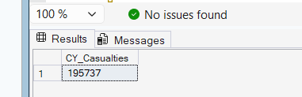

CY Accidents

SELECT COUNT(*) AS Accidents_2022
FROM road_accident
WHERE accident_date >= '2022-01-01'
AND accident_date < '2023-01-01';

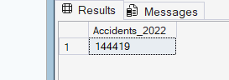

Fatal Casualties

SELECT SUM(number_of_casualties) AS Fatal_Casualties_2022
FROM road_accident
WHERE accident_severity = 'Fatal'
AND accident_date >= '2022-01-01'
AND accident_date < '2023-01-01'

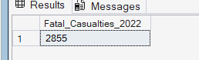

Note : From here down i’ve decided to take the whole screenshot together

Serious Casualties

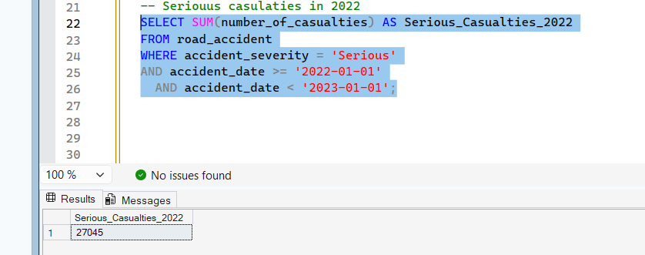

CY SLIGHT CASUALTIES

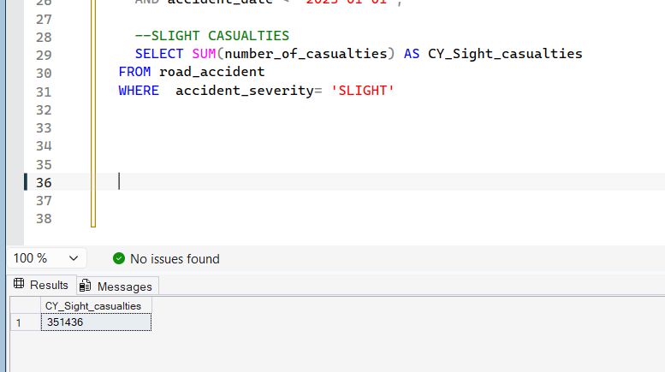

— SLIGHT PERCENTAGE IN 2022

SELECT
SUM(CASE WHEN casualty_severity = 3 THEN 1 ELSE 0 END) * 100.0
/ COUNT(*) AS slight_percentage
FROM Accidents;
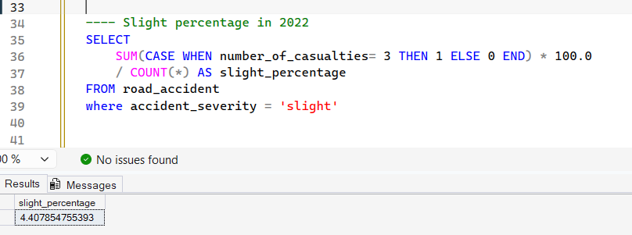

SELECT CASUALTIES BY VEHICLE TYPE ( GROUPS )
Note : Select statements had to be used in the group order we’ve created earlier on power BI

SELECT
CASE
WHEN vehicle_type LIKE '%Agricultural%' THEN 'Agricultural'
WHEN vehicle_type LIKE '%Motorcycle%'
OR vehicle_type LIKE '%Bike%'
OR vehicle_type LIKE '%Scooter%' THEN 'Bike'
WHEN vehicle_type LIKE '%Bus%' OR vehicle_type LIKE '%Coach%' THEN 'Bus'
WHEN vehicle_type LIKE '%Car%' OR vehicle_type LIKE '%Taxi%' THEN 'Car'
WHEN vehicle_type LIKE '%Van%' THEN 'Van'
ELSE 'Other'
END AS vehicle_group,

SUM(number_of_casualties) AS total_casualties

FROM road_accident
GROUP BY
CASE
WHEN vehicle_type LIKE '%Agricultural%' THEN 'Agricultural'
WHEN vehicle_type LIKE '%Motorcycle%'
OR vehicle_type LIKE '%Bike%'
OR vehicle_type LIKE '%Scooter%' THEN 'Bike'
WHEN vehicle_type LIKE '%Bus%' OR vehicle_type LIKE '%Coach%' THEN 'Bus'
WHEN vehicle_type LIKE '%Car%' OR vehicle_type LIKE '%Taxi%' THEN 'Car'
WHEN vehicle_type LIKE '%Van%' THEN 'Van'
ELSE 'Other'
END

ORDER BY total_casualties DESC;

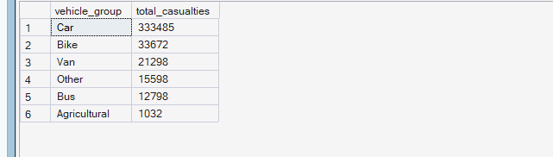

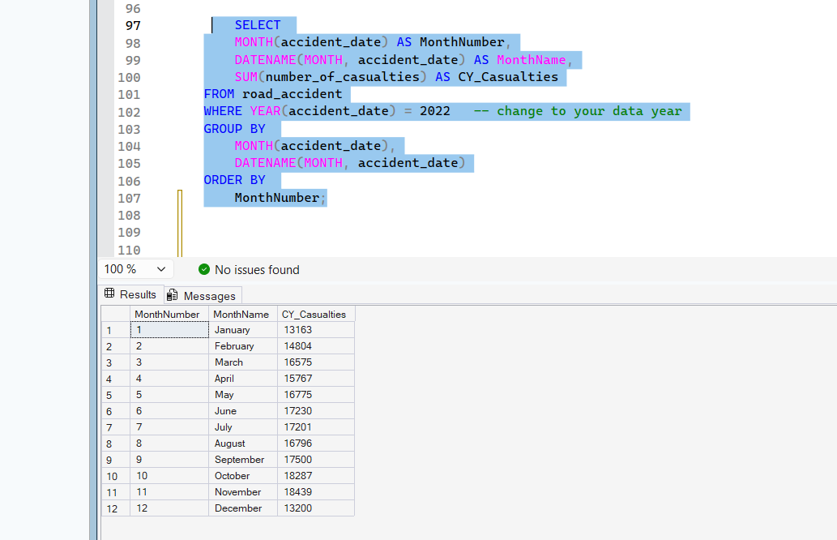
Above / KPI CY Casualties by months

Kpi Casualties by road type

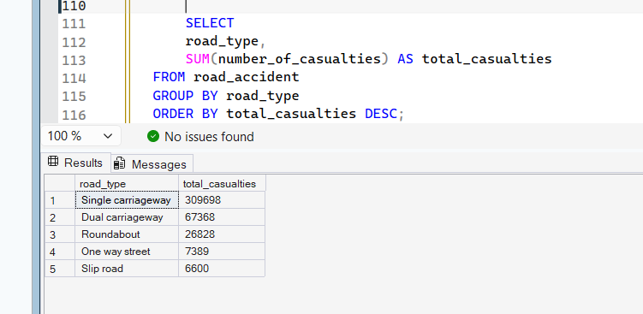

— kpi Casualties by urban or rural areas

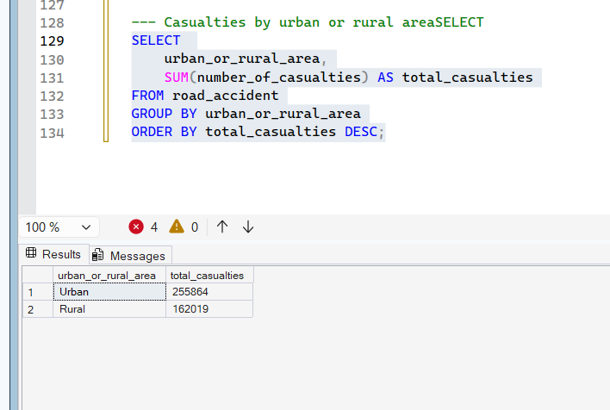

With Percentage %% 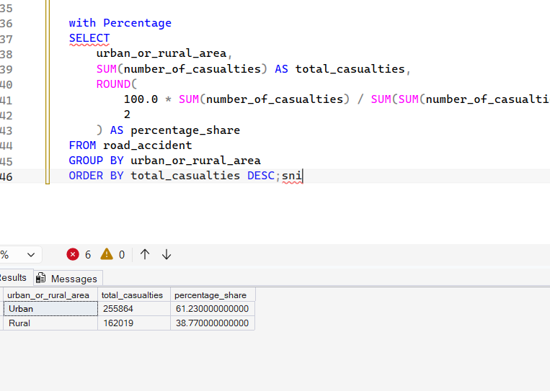

Kpi Casualties By LIGHT Conditions

KPI top 10 places by casualties
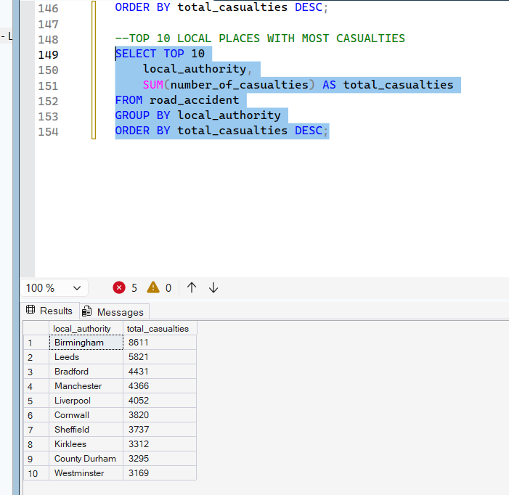

Insights Great dataset!

Column | Type | Notes
accident_index | string | Unique ID per accident
accident_date, time | string | 2 years of data, 730 unique dates
accident_severity | string | Slight / Serious / Fatal
number_of_casualties | int | 1–48, avg 1.36
number_of_vehicles | int | Numeric
vehicle_type | string | 15 types, 78% are Cars
weather_conditions | string | 8 categories
road_type | string | Single carriageway dominates
speed_limit | int | 10–70 mph
light_conditions | string | Daylight vs darkness types
urban_or_rural_area | string | 64% Urban, 36% Rural
day_of_week | string | Friday has most accidents
local_authority, police_force | string | Geographic grouping

Interesting angles worth exploring:
- Friday has the most accidents (~50k) — could signal rush-hour/weekend effect
- 74% of accidents happen in daylight, but darkness accidents may have higher severity (worth a query)
- Fatal accidents are only 1.3% of total — good for a CASE WHEN severity classification
- Speed limit 30 has by far the most accidents (200k) simply due to volume of 30mph roads

My Recommendations based on the insights

Peak time interventions Friday is the worst day — staggered work hours, increased traffic enforcement, and variable speed limits on Fridays could directly cut numbers. Most accidents happen in daylight during commute hours, so rush-hour signal timing optimization matters more than lighting upgrades.
Speed limit enforcement on 30mph roads 200,040 accidents happened in 30mph zones — the highest of any speed limit. This isn't just because there are more 30mph roads; it signals that urban speed compliance is poor. Recommendations: average speed cameras on high-incident streets, more pedestrian crossings, and road narrowing (chicanes) to physically enforce lower speeds.
Rural road investment Rural areas are 36% of accidents but likely a much higher share of fatalities given higher speeds. Priorities should be better road markings, rumble strips on single carriageways, and emergency response time reduction since rural fatal accidents often worsen due to delayed ambulance arrival.
Single carriageway upgrades 230,000+ accidents on single carriageways — adding passing bays, center line rumble strips, and overtaking prohibition signs on high-risk stretches would help. Where budget allows, converting high-incident single carriageways to dual is the most effective fix.
Weather-responsive infrastructure Rainy conditions account for ~37k accidents. Recommendations: better surface drainage, high-grip road surfaces at junctions and bends, and dynamic message signs that warn drivers in real time when roads are wet or icy.
Motorcycle-specific policy Motorcycles (all types combined) are heavily overrepresented in serious/fatal accidents relative to their volume. Targeted actions: dedicated motorcycle safety awareness campaigns, better road surface maintenance on popular motorcycle routes, and advanced riding courses offered at reduced cost.
Data-driven patrol deployment Your local_authority and police_force columns can identify the top 10 hotspot authorities — police forces should reallocate patrol hours to match accident concentration rather than distributing evenly across a region.
Junction redesign The junction_detail and junction_control columns likely reveal that uncontrolled junctions are a major contributor. Converting T-junctions to mini-roundabouts consistently reduces injury accidents by 50–70% in UK studies and is relatively low cost.

